Cole Nielsen

LA 1201

Exercise 1

TA: Rachel Kerber

**BRIEF INTRODUCTION:**

The site that I observed for this exercise was the river flats below the Washington Avenue Bridge on West Bank (the “west river flats”). The site is essentially an open grass field with a hill sloping up to a parking lot on one side, and along the other side there is a fence that runs along the river. In the park there are some cement sidewalks, along with a little pavilion, a porta-potty and a small building that houses river cruise company. The river flats I observed seem to serve as a port for the river cruise company there, as they have several boats docked along the edge of the river at the park.

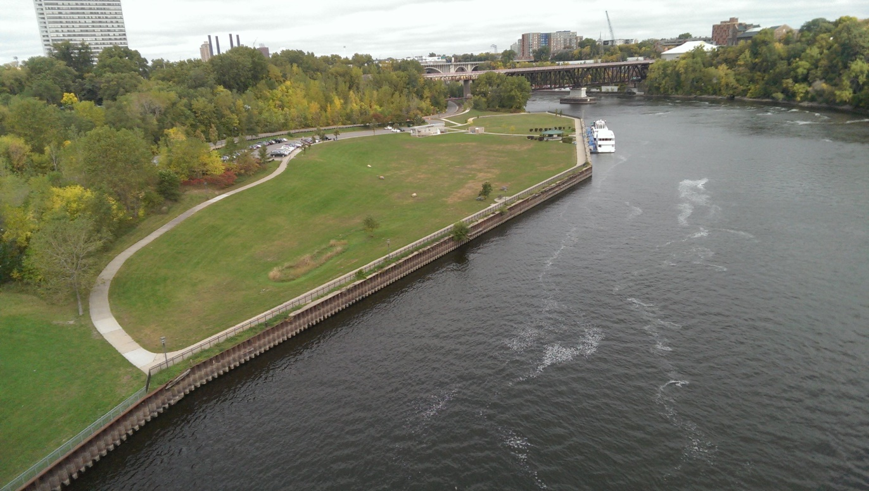

**Above: View of site from Washington Avenue Bridge**

I looked for several things in the river flats based upon Zeisel’s reading. Since the location is a park, I tried to look for evidence of recreation activities that may be playing in its large field such soccer or Frisbee. Also upon seeing the river cruise company was located in the park, I tried to look for physical traces to like a boat pass to as evidence that people actually got on the boats here. Another thing I looked for were traces that were constructed such as the sidewalks to give the area a certain use. In a wider scope, I realistically tried to look for any traces I could see of human activity that has occurred in the park. When I talk about traces, I mean things, such as built structures, trails, litter that have been left behind by humans and that give us insight into how the place is used and who uses it.

**SITE MAP:**

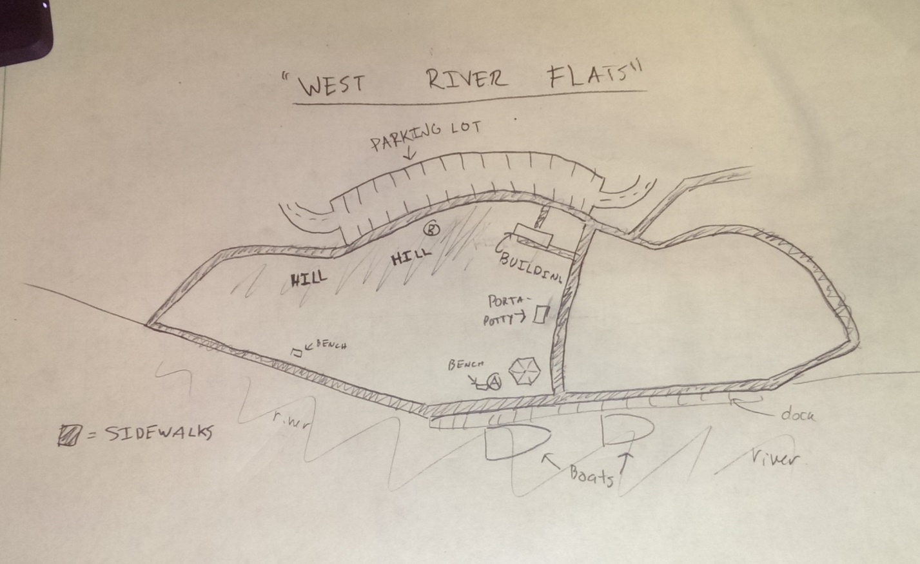

During my first observation, I walked a full loop around the sidewalks the go around the park and then I sat at the bench where the circled A is and wrote down observations. My first observation took place at around 10 AM on 9/30. My second round of observations started out with me sitting at the spot labeled with the B in a circle on the hall and I took notes. After that I took another loop around the park and wrote/noted any further observations. The sidewalks are indicated by the shaded regions enveloping the park, and everything else is labeled so it should be somewhat self-explanatory. The image above the map of the park taken from the bridge also gives a good map-like perspective of the location that may provide further detail of the location.

**FIELD NOTES:**

I visited the west river flats two times on 9/30, the first time being at around 10 AM in the morning and the second at around 4 PM in the afternoon. It was cold during the first session at around 40 degrees, and the sky completely clouded over. It was a bit warmer in the high 50’s for the second session, however it was still cloudy.

**OBSERVATION SESSION 1 (Morning 9/30):**

Upon arriving to my site the first thing I noticed was the utter lack of people. This lack of people persisted throughout the whole entire time I was there. This was probably attributable to the fact that it was cold and in the morning of a weekday. I also immediately noticed that the parking lot in the sight was nearly full, which suggests a popular use of this site is for parking. Upon reaching the field in the center of the flats I noticed that it there was a hill on the side by the parking lot, and that there is a sidewalk the wraps around the perimeter of the flats. As I started to walk around the perimeter on the sidewalks of the site I noticed the some construction towards the road that passes by the flats:

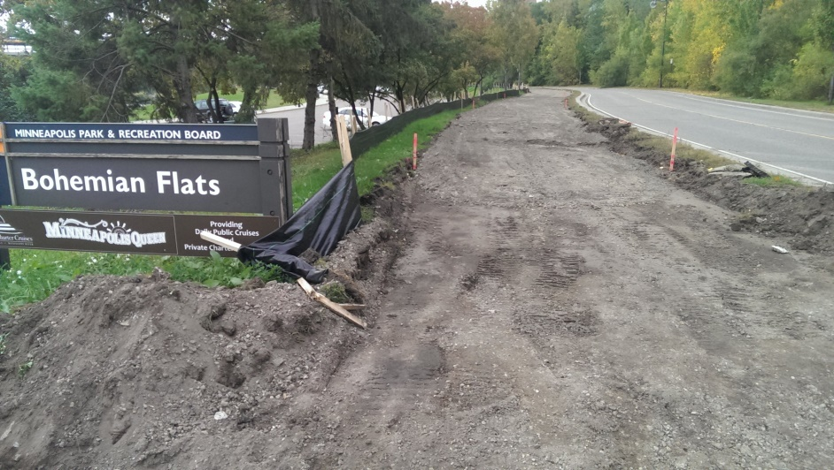

As I approached the waterfront of the river that runs along part of the park, I noticed the fence that runs the whole length of the waterfront, likely to prevent people from accessing and being endangered by the river. As I made my way about half way down the length of the waterfront, I approached a break in the fence a few feet across that lead to a dock along the waterfront with several boats parked at it. There were warnings to not trespass and that the site is “under surveillance”. Presumably the dock and boats are part of the river cruise company that has a small building on the river flats near the parking lot. Right next to the break in the fence I also noticed some graffiti marked onto the concrete, which is a sign of human activity (illicit) occurring in the park.

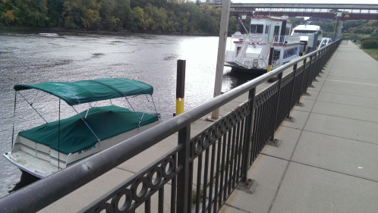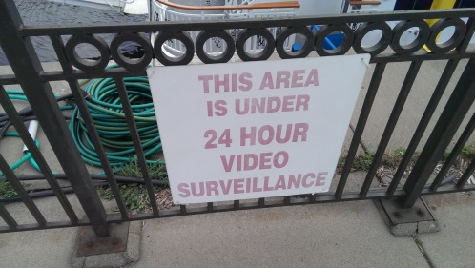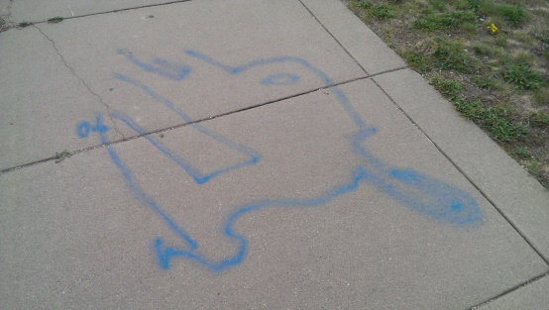

Right next to the break in the fence that leads to the dock there was also some shrubs, a hexagonal pavilion with nothing underneath it, a bench a cement path that goes past the river cruise building to the parking lot. Also along the path is a porta-potty. After noting that I sat down at the bench, where I began to notice bits of litter lying around this part of the sight, suggesting it is high-trafficked.

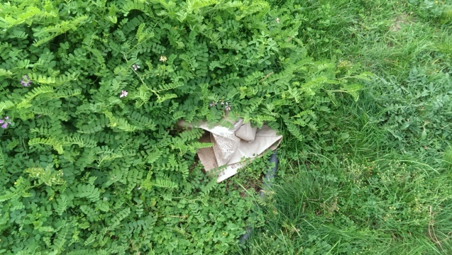

**OBSERVATION SESSION 2: (Afternoon 9/30)**

Upon arriving for my second observation session I noticed it was considerably warmer outside, yet just as cloudy. Again, there was essentially no one there, with the exception of a couple of people working on the boats and a couple driving their cars out of the parking lot in the flats. Only seeing people going to the cars suggests that a primary use of the park it being just parking space. After sitting down on the hill marked as the B in the circle, I noticed the wear patterns in the grass of the field:

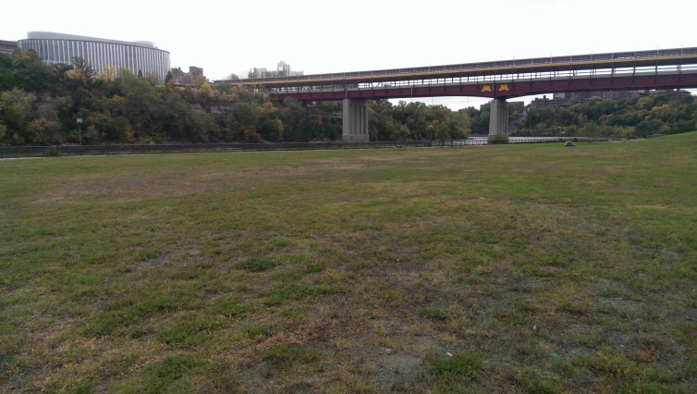

The grass appeared to be only warn in the level parts below the hill, which they are most used and the hills aren’t really used at all. They also suggest recreation, perhaps soccer or Frisbee being played there. After sitting there a little while longer and observing the site, I began to notice that people where almost avoiding the site, as runners and other people who would pass by the sight would go past it without going through it.

**DIFFICULTIES AND CHALLENGES:**

One major difficulty I had was that I had trouble finding new observations during my second trip to the site. I attribute this to the fact that it seems that no one went to the park all day (or extremely few people). As a result my observations for the second trip were very few and mainly highlighted things from my first time there. Another difficulty I had was that I didn’t really see any people, so that limited my observations to just what I saw laying around and not of what I saw people interacting with the environment. I also had trouble finding a lot of traces that weren’t constructed things to point to human behavior. Essentially the only non-constructed thing things were the wear patterns in the grass, some litter and one graffiti glyph.

Some general reflections I have regarding my observations are that first that the park mainly seems to be a parking lot from what I saw today (a large amount of the live human activity was people accessing their cars and the full lot points to a lot of people parking and being active in the lot). Another remark I have is that the park also seems to function largely as a port for the river boat company, as there is a parking lot conveniently located in the flats for them and they have their little building and boats parked there. The placement of the river cruise things on the west river flats suggest that river cruises from this spot are relatively prolific and define the usage of spot pretty well. Lastly, regarding recreational usage of the park, the wear patterns of the grass mostly point to a fair level of recreation (dogs, Frisbee, soccer?) in the park and point to human behaviors relating to recreation in the spot.